
Physics
Written Paper Stage 2A
Question/Answer Booklet

Student name: ____________________________________

Time allowed for this paper
Reading time before commencing work: Ten minutes
Working time for paper: Two and a half hours

Material required/recommended for this paper

To be provided by the supervisor
This Question/answer booklet; Formulae and constants sheet

To be provided by the candidate
Standard items: pens, pencils, eraser or correction fluid, ruler, highlighter
Special items: scientific non-programmable calculator

Important note to candidates
No other items may be taken into the examination room. It is your responsibility to ensure that you do not have any unauthorised notes or other items of a non-personal nature in the examination room. If you have any unauthorised material with you, hand it to the supervisor before reading any further.

All calculations are to be set out in detail. Marks may be awarded for correct equations and clear setting out, even if you cannot complete the calculation. Express numerical answers to two (2) or three (3) significant figures and include units where appropriate.
Student Marks
Section |  | Maximum mark | Student mark Raw | Student Scaled Mark
Section One  15 - 20 questions | Short Answer  40% of exam | 59 |  | out of 40
Section Two  5 – 7 questions | Problem Solving  50% of exam | 64 |  | out of 50
Section Three  1 -2 questions | Comprehension  10% of exam | 17 |  | out of 10
Student Percentage
Structure of this paper
Section of exam | Suggested working time | Number of questions | Number of questions to be attempted | Marks available
Section One | 65 minutes | 17 | all | 59
Section Two | 65 minutes | 6 | all | 64
Section Three | 20 minutes | 1 | all | 17
 |  |  | [Total marks] | 140
Instructions to candidates

- The rules for the conduct of WACE examinations are detailed in the Student Information Handbook. Sitting this examination implies that you agree to abide by these rules.
- Answer all questions in the spaces provided in this Question/Answer Booklet. Answers should be given to the appropriate number of significant figures.
- A blue or black ballpoint or ink pen should be used.
- You must be careful to confine your responses to the specific questions asked and to follow any instructions that are specific to a particular question.
- Spare pages are included at the end of this booklet. They can be used for planning your responses and/or as additional space if required to continue an answer.
  - Planning: If you use the spare pages for planning, indicate this clearly at the top of the page.
  - Continuing an answer: If you need to use the space to continue an answer, indicate in the original answer space where the answer is continued, i.e. give the page number. Fill in the number of the question(s) that you are continuing to answer at the top of the page.

Section one: Short answer 40% (59 marks)
This section has seventeen (17) questions. Answer in the spaces provided.
Suggested working time: 65 minutes. [ 60 Marks total]
Question 1 (4 marks)
a. Complete the following table: (2 marks)

Element | Number of Protons | Number of Neutrons | Mass Number
Carbon (C) | 6 |  | 12
Lead (Pb) | 82 | 126
Radium (Ra) |  | 138
Uranium (U) | 92 |  | 238

b. Which of the columns represents the Atomic Number? (1 mark)

c. Which column(s) would change for a different isotope of lead? (1 mark)

Question 2 (4 marks)
Complete the following nuclear equations by filling in the spaces:
a.
235 |  | → |  |  | +
 | U | → |  | Th | + |  | α
92 | Uranium | → |  | Thorium | + |  | alpha

14 |  | → |  |  | +
 | C | → |  | N | + |  | e
6 | Calcium | → |  | Nitrogen | + |  | beta
b.

Question 3 (3 marks)
A car is driving along the road at 60.0 km h⁻¹ when the speed limit changes to 80.0 km h⁻¹. Draw a free body diagram to illustrate the forces on the car during the time the car is accelerating to the new speed limit.

Question 4 (4 marks)
Thorium-234 will decay to Protactium-234. Thorium-234 has a half life of 24.1 days, and Protactinium-234 has a half life of 6.75 hours.
a. How does the weight of the same number of atoms of Thorium -234 compare to the same number of atoms Protactinium -234?
Circle the correct answer: GREATER EQUAL SMALLER
b. Given the same number of atoms of Thorium -234 and Protactinium -234, which sample would have the greatest number of decays per second?
Circle the correct answer: Thorium -234 EQUAL Protactinium -234
c. What happens to the weight of a sample of Thorium -234 when half of it has it decayed to Protactinium -234?
Circle the correct answer: DOUBLES EQUAL HALVES
d. Explain why you have chosen this answer. _________________________________________
___________________________________________________________________________
___________________________________________________________________________
___________________________________________________________________________
___________________________________________________________________________
___________________________________________________________________________
Question 5 (5 marks)
A student takes 45.0 minutes to walk to school which is 2.60 km, due west from her house.

a. Calculate is her average velocity? (3 marks)

b. In reality the distance she travels is really 3.20 km, because of the route she takes, calculate her average speed? (2 marks)

Question 6 (5 marks)

A force of 12.0 N is applied to a trolley at rest with a mass of 1.50 kg. After a period of time the trolley has a velocity of 34.0 ms^{-}. Calculate:

a. the acceleration of the trolley. (2 marks)

- the time taken for the trolley to reach the velocity of 34.0 m s^{-}. (If you are unable to calculate acceleration use the value of 10.0 m s⁻².) (3 marks)

Question 7 (5 marks)

In 1988, several pieces from the Shroud of Turin were sent to be radiocarbon dated. Although the results from the experiment may be flawed from the source of the data, answer was still reasonably precise. The results from one laboratory gave the ages as
1273 ± 25 years, 1312 ± 25 years and 1331 ± 25 years

a. Calculate the average age from the data recorded. (2 marks)

b. The same laboratory was analysing a sample with a known half-life of 3.00 days. When they received the sample it had an activity of 230 kBq. Determine its activity 15.0 days later?
(3 marks)

Question 8 (3 marks)

Consider a fully outfitted astronaut who has a combined mass of 1.51 x 10² kg. If she were to travel to the moon where the acceleration due to gravity is 1.67 m s⁻², explain how would her:

a. mass would change? (1 mark)

b. weight would change? (Include a calculation) (2 marks)

The following information is used for questions 9-10.

The figure shows two industrial spies sliding an initially stationary 225 kg floor safe a displacement d of 8.50 m, straight toward their truck. The horizontal push F1 of Spy 001 is 10.0 N the horizontal pull F2 of Spy 002 is 12.0 N. The magnitudes and directions of these forces do not change as the safe moves, and the floor and safe make frictionless contact.

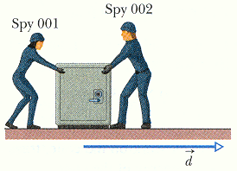
Question 9 (3 marks)

Determine the acceleration of the floor safe?

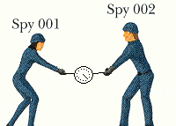

Question 10 (2 marks)

If the safe were replaced by a force measuring scale and the spies maintained their original forces, determine the reading on the scale. (Hint: a vector diagram might help you!)

Question 11 (3 marks)

A bee with a mass of 0.150 g lands on one end of a floating 4.75 g pop stick. After sitting at rest for a moment, it runs toward the other end of the pop stick with a velocity v_{b} relative to the still water. The stick moves in the opposite direction with a speed of 0.120 cm s⁻¹.

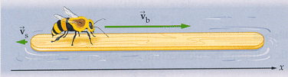

a. Explain why the pop stick and the bee move in opposite directions. (1 mark)

__________________________________________________________________________________________________________________________________________________________________________________________________________________________________________________________________________________________________________________________________________________________________________________________________________________________________________________________________________________________________________________________________________________________________
__________________________________________________________________________________________________________________________________________________________________________________________________________________________________________
b. Use the principle of conservation of momentum to explain the difference in the speed of the bee and the pop stick. (2 marks)

________________________________________________________________________________________________________________________________________________________________________________________________________________________________________________________________________________________________________________________________________________________________________________________________________________________________________________________________________________________________________________________________________________________________________________________________________________________________________________
____________________________________________________________________________________________________________________________________________________________
Question 12 (3 marks)

It takes a force of 1280 N to keep a 1.50 x 10³ kg car moving with a constant speed up a slope of 5.00˚. If the engine delivers 150 kW to the drive wheels, determine the maximum speed of the car?

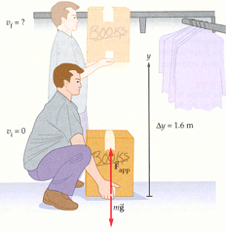
The following information is for Questions 13-14.
A 4.10 kg box of books is lifted vertically from rest a distance of 1.60 m by an upward applied force of 60.0 N.

Question 13 (2 marks)

Calculate the work done by the applied force

Question 14 (4 marks)

Calculate the acceleration of the box.

Question 15 (3 marks)

A car, travelling at 16.0 m s⁻¹, slows down over 20.5 m with a deceleration of 3.45 m s⁻² as it approaches a school. Calculate the car’s velocity as it passed the school.

Question 16 (4 marks)

Using your understanding of physics principles, explain why cars are designed to crumple when they hit something.

__________________________________________________________________________________________________________________________________________________________________________________________________________________________________________________________________________________________________________________________________________________________________________________________________________________________________________________________________________________________________________________________________________________________________
____________________________________________________________________________________________________________________________________________________________________________________________________________________________________________________________________________________________________________________________________________________________________________________________________________________________________________________________________________________
Question 17 (3 marks)
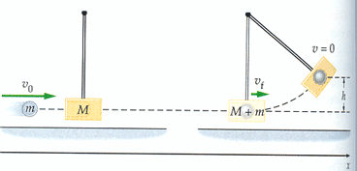
In a ballistic pendulum, an object of mass m is fired with an initial speed υ_{o} at the bob of a pendulum. The bob has a mass M, and is suspended by a rod of negligible mass. After the collision, the object and the bob stick together and swing through an arc, eventually gaining a height h. Determine the height h in terms of m, M, υ_{o}, and g.

Section two: Problem-solving 50% (64 marks)

This section has six (6) questions. Answer in the spaces provided.
Suggested working time: 65 minutes.
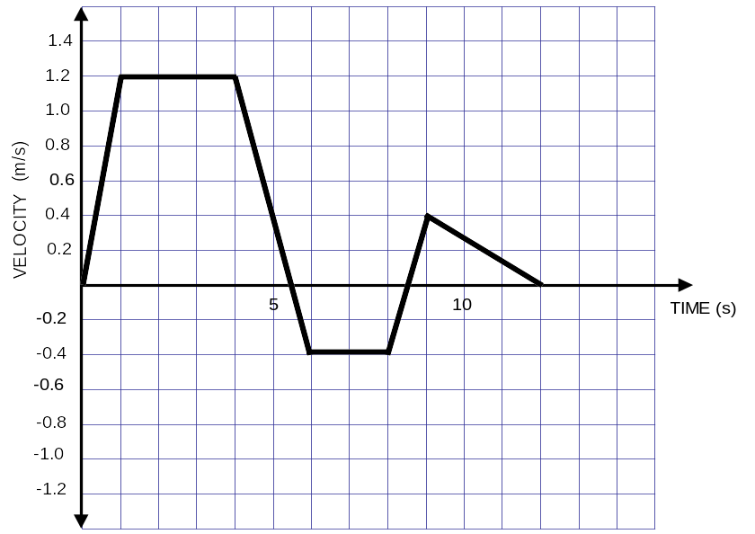
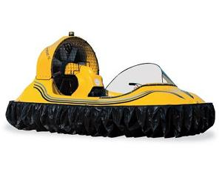
Question 18 (9 marks)

A physics student is experimenting with his toy hovercraft. He uses a motion sensor connected to a computer to produce a velocity-time graph of its motion. The graph produced by the computer is shown to the right. His hovercraft starts in an EASTERLY direction.

a. During what time interval or intervals was the acceleration of the hovercraft zero?
(2 marks)
________________________________________________________

b. At what time did the hovercraft first change direction?
(1 mark)
________________________________________________________

c. Calculate the maximum acceleration of the hovercraft during the experiment.
(3 mark)

d. Using the information in the graph, determine the displacement of the hovercraft from its starting point after 4 seconds? (3 marks)
Question 19 (9 marks)

An intern pushes a 72.0 kg patient on a 15.0 kg gurney, producing an acceleration of 0.600 m s⁻². Assume the gurney moves without friction.
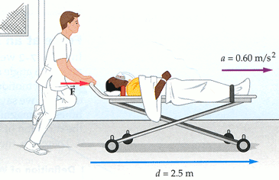

a. Determine how far will they have travelled after 2.40 seconds? (2 marks)

b. Determine how far will they have travelled by the time they achieve a speed of 4.00 m s⁻¹.
(3 marks)

c. Calculate the deceleration needed to stop the patient and gurney in 2.00 s from that speed?
(2 marks)

d. Calculate the force the intern is required to use to stop the gurney and patient in the 2.00 s. (if you were unable to determine the acceleration in (c), use the value 3.00 m s⁻²) (2 marks)

Question 20 (14 marks)

An 80 kg nuclear technician inadvertently exposes himself to 30 Joules of Gamma radiation. He has done this through eating in the lab – not following the rules!

a. Determine his absorbed dose? (2 marks)

b. Determine his dose equivalent? (2 marks)

c. Using the table, explain the likely effect from this radiation exposure? (2 marks)
Dose Equivalent (Sv) | Body damage
0.25 | Reduction in white blood cell count
1 | Possible nausea, vomiting.
4 | Nausea, diarrhoea, drop in blood cell count.
5 | Loss of hair, 50% die.
10 | Severe damage to central nervous system, death within days

__________________________________________________________________________
__________________________________________________________________________
__________________________________________________________________________
___________________________________________________________________________
__________________________________________________________________________
__________________________________________________________________________
__________________________________________________________________________
d. Compare how the dose equivalent would be different and what effects this would have on the nuclear technician if it had been an alpha source instead? (4 marks)

__________________________________________________________________________
__________________________________________________________________________
__________________________________________________________________________
__________________________________________________________________________
__________________________________________________________________________
__________________________________________________________________________
__________________________________________________________________________
__________________________________________________________________________
__________________________________________________________________________
__________________________________________________________________________
__________________________________________________________________________
__________________________________________________________________________
__________________________________________________________________________
__________________________________________________________________________
__________________________________________________________________________
__________________________________________________________________________
__________________________________________________________________________
__________________________________________________________________________
__________________________________________________________________________
__________________________________________________________________________
__________________________________________________________________________
__________________________________________________________________________
__________________________________________________________________________
__________________________________________________________________________
__________________________________________________________________________
__________________________________________________________________________
__________________________________________________________________________
Question 21 (12 marks)
A 0.450 kg ball travelling at 20.0 m 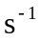south hits a wall and bounces off at a velocity of 16.0 m north. The ball is in contact with the wall for 2.50 × 10⁻² s.

a. Calculate the initial momentum of the ball? (2 marks)

b. Calculate the change in momentum of the ball? (3 marks)

c. Calculate the impulse on the ball? (2 marks)

d. Determine the magnitude of the force exerted on the ball by the wall? (If you could not determine the Impulse in the above question, use the value 18.0 Ns) (3 marks)

e. Explain what has happened to the energy lost in the collision? (2 marks)
___________________________________________________________________________
___________________________________________________________________________
___________________________________________________________________________
___________________________________________________________________________
Question 22 (13 marks)
Uranium - 233 can undergo fission when struck by a thermal neutron producing many different types of splits. One possible split is shown in the following formula:

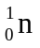 + 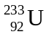 → 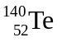 + 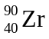 + _____ + energy

a. How many neutrons are released during this fission process? (e.g. fill in the blank above.) (1 mark)

b. Given the atomic mass unit in the table for the above reaction, calculate the amount of the mass defect in kilograms for this fission process. (3 marks)
Isotope | Mass (u)
Neutron | 1.008665
Uranium – 233 | 233.039635
Tellurium - 140 | 139.938854
Zirconium - 90 | 89.904708

c. Calculate the energy released during the fission of one Uranium - 233 () atom. (If you were unable to determine the mass defect in (b), use the value 3.00 x 10⁻²⁸kg) (4 marks)

d) The first British atomic test in Australia on the 3rd of October 1952 on the Monte Bello Islands had a yield of 25 kt, or about 1 x 10¹⁵ J. Assuming the above energy release (part c) is the average per Uranium - 233 () atom and was the main constituent, what mass of atoms underwent fission during this test? (3 marks)

e) This mass of Uranium - 233 is higher than the ‘critical mass’ value written in your text book. Explain what ‘critical mass’ means, and how the engineers were able to transport this mass without the bomb going ‘supercritical’ and exploding at the assembly site? (2 marks)

___________________________________________________________________________________________________________________________________________________________________________________________________________________________________________________________________________________________________________________________________________________________________________________________________________________________________________________________________________________________________________________________________________________________________________________________________________________________________________________________________________________________________________________________________________________________________________________________________________________________________________________________________________________________________________________________________________________________________________________________________________________________________________________________________________________________________________________________________________________________________________________________________________________________________________________________________________________________________________________________
Question 23 (7 marks)

An accident involving a Toyota Camry Grande occurred outside of the high school grounds. A group of keen physics students decided to investigate the accident to try and find out how fast the car was going before the accident occurred.

The students measured the length of the skid marks on the road and then after research on the internet found that by using the following formulas they could determine the speed (in ms⁻¹) of the Toyota Camry.

s² = 250d × f (s = speed, d= length of skid mark, f = friction coefficient) ……. eqn 1

The coefficient of friction depends on the nature of the road i.e. bitumen, cement, gravel etc.
The formula for the coefficient of friction 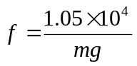 …………………………. eqn 2
(where m = mass of the car in kg and g = acceleration due to gravity)

a. If the mass of the Camry is 1530 kg calculate the weight of the car. (2 marks)

b. Use the weight of the car to calculate a value for the coefficient of friction. (2 marks)

c. If the length of the skid mark was 2.75 m calculate the speed of the car. (If you were unable to determine the coefficient of friction in (b), use f = 0.50). (3 marks)

Section three: Comprehension 10% (17 marks)
This section has one (1) question. Answer in the spaces provided.
Suggested working time: 20 minutes.
Question 24 (17 marks)
A group of physics students carried out an investigation on the range of beta particles in air. Using a Geiger–Muller tube attached to a counter the students recorded the background count over a two minute period. They then recorded the activity of a beta source (Strontium-90) at range of distances between the Geiger–Muller tube and the source. The results of their investigation are shown below:

Results:

Background count = 64 counts over two minutes

a. Complete the table by calculating the actual count per minute. (3 mark)

Distance between source and GM tube (cm) | Counts in one minute | Actual count  per minute
10 | 2820
15 | 2370
25 | 1433
30 | 990
45 | 485
55 | 285
65 | 229
80 | 153

b. On the graph paper on the next page, plot the distance vs the actual count of the source and draw a trend line that best represents the data. (5 marks)

c. Describe two changes that could be made to this investigation to improve the reliability of the results. In your answer explain how the changes would reduce the uncertainties in the measurements. (4 marks)

Change 1:
____________________________________________________________________________________________________________________________________________________________________________________________________________________________________________________________________________________________________________________________________________________________________________________________________________________________________________________________________________________________________________________________________________________________________________________________________________________________________________________________________________________________________________________________________________________________________________________________________________________________________________________________________________________________________________________________________
Change 2:
____________________________________________________________________________________________________________________________________________________________________________________________________________________________________________________________________________________________________________________________________________________________________________________________________________________________________________________________________________________________________________________________________________________________________________________________________________________________________________________________________________________________________________________________________________________________________________________________________________________________________________________________________________________________________________________________________
d. If the beta source was replace with alpha source, draw on the same graph a count vs distance graph for the alpha source. Assume an initial activity of 2500 counts per minute at 1cm form the Geiger–Muller tube and that the typical penetrating range of the alpha particles from this source is 20 cm. (3 marks)

End of Exam
Spare pages
__________________________________________________________________________________________________________________________________________________________________________________________________________________________________________________________________________________________________________________________________________________________________________________________________________________________________________________________________________________________________________________________________________________________________
__________________________________________________________________________________________________________________________________________________________________________________________________________________________________________________________________________________________________________________________________________________________________________________________________________________________________________________________________________________________________________________________________________________________________
__________________________________________________________________________________________________________________________________________________________________________________________________________________________________________________________________________________________________________________________________________________________________________________________________________________________________________________________________________________________________________________________________________________________________
__________________________________________________________________________________________________________________________________________________________________________________________________________________________________________________________________________________________________________________________________________________________________________________________________________________________________________________________________________________________________________________________________________
Spare pages
__________________________________________________________________________________________________________________________________________________________________________________________________________________________________________________________________________________________________________________________________________________________________________________________________________________________________________________________________________________________________________________________________________________________________
__________________________________________________________________________________________________________________________________________________________________________________________________________________________________________________________________________________________________________________________________________________________________________________________________________________________________________________________________________________________________________________________________________________________________
__________________________________________________________________________________________________________________________________________________________________________________________________________________________________________________________________________________________________________________________________________________________________________________________________________________________________________________________________________________________________________________________________________________________________
__________________________________________________________________________________________________________________________________________________________________________________________________________________________________________________________________________________________________________________________________________________________________________________________________________________________________________________________________________________________________________________________________________

